Telescopic Surveying Pole
SKU: GPS-25795
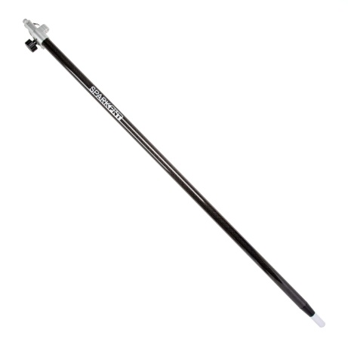
Product Overview
The SparkFun telescoping pole is perfect for GNSS projects that require mobility and ease of use. Get your point heights dialed in to the millimeter! This lightweight carbon fiber pole weighs less than 2.1 lbs (1.0kg) and can be extended from 1.3 to 2.2m. The 5/8" 11-TPI industry standard threaded connector includes a rubber o-ring to hold the GNSS device securely in place. Pole includes a bubble level and a d-shaped tube that prevents internal spinning. The threaded tip protector is extremely handy for both protecting the tip and avoiding loss of the protector.
This is a perfect add-on for most of our popular PNT products like the RTK Facet + L-Band Version, Torch, GNSS Multi-Band Antenna, and RTK Express Kits.
Note: This product only includes a Surveying Pole and a carrying bag.

Includes:
- 1x Telescopic Surveying Pole
- 1x Carrying Bag
Features & Specs:
Threaded tip protector Threaded replaceable tip Extension length: 1.3 to 2.2m Packing dimensions: 45 x 4.5 x 3" (1.36 x 0.11 x 0.075m) Packing weight: 3.0lbs (1.36kg)

