Macchina OBD-II Extender Cable
SKU: CAB-25070
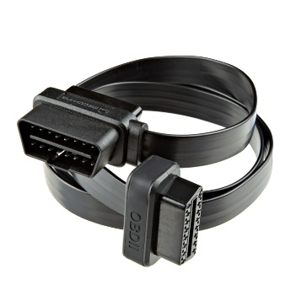

Product Overview:

This custom-designed OBD-II cable from Macchina functions as both a splitter and at about one meter (~39 inches) in length, as an OBD-II extension cable. Unlike other cables out there, all 16 pins connected between each connector, eliminating troubleshooting headaches. We’re confident you’ll find this OBD-II cable more useful than anything else out there.

Features & Specs:
- 1 Meter Long
- Splits to both a Male and Female connector

