
PTFE insulated Twin Twisted IEC Exposed Junction Thermocouple with Miniature Plug - Type T – 2m
XE-3526-001
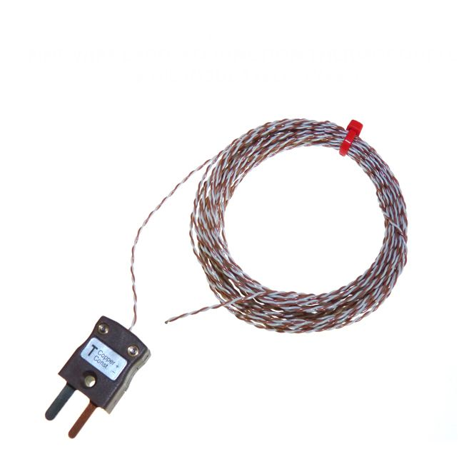

Labfacility are the UK’s leading manufacturer of Temperature Sensors, Thermocouple Connectors and associated Temperature Instrumentation and stockists of Thermocouple Cables. The Company has been trading since 1971 and is ISO 9001 accredited.

Specifications
General Description | Fast response, welded exposed junction
Sensor Type | Exposed Junction
Thermocouple Type | T
Cable Length | 2m
Cable Type | Teflon® PTFE insulated twin-twisted lead
Core / Strands | 1/0.2mm
Termination Type | Miniature flat pin plug colour coded in accordance IEC 584 or bare tails
Max. Temperature | +260°C
Min. Temperature | -75°C
Tolerance | Class 1
Standards Met | IEC-584-3
Connector Type | Plug
Connector Size | Miniature

Ordering Information
Thermocouple Type | Colour Code | Core/Strands | Length | Termination | Order Number
T | IEC | 1/0.2mm | 2m | Miniature Plug | XE-3526-001

